

# 

### Semester One Examination, 2016

### Question/Answer Booklet

# MATHEMATICS

If required by your examination administrator, please place your student identification label in this box

**METHODS**

**UNIT 3**

## Section Two:

## Calculator-assumed

|  |  |  |  |  |  |  |  |  |
| --- | --- | --- | --- | --- | --- | --- | --- | --- |
| Student Number: In figures |  |  |  |  |  |  |  |  |

In words

Your name

## Time allowed for this section

Reading time before commencing work: ten minutes

Working time for section: one hundred minutes

## Materials required/recommended for this section

***To be provided by the supervisor***

This Question/Answer Booklet

Formula Sheet (retained from Section One)

***To be provided by the candidate***

Standard items: pens (blue/black preferred), pencils (including coloured), sharpener, correction fluid/tape, eraser, ruler, highlighters

Special items: drawing instruments, templates, notes on two unfolded sheets of A4 paper, and up to three calculators approved for use in the WACE examinations

## Important note to candidates

No other items may be taken into the examination room. It is **your** responsibility to ensure that you do not have any unauthorised notes or other items of a non-personal nature in the examination room. If you have any unauthorised material with you, hand it to the supervisor **before** reading any further.

## Structure of this paper

|  |  |  |  |  |  |
| --- | --- | --- | --- | --- | --- |
| Section | Number of questions available | Number of questions to be answered | Working  time (minutes) | Marks available | Percentage of exam |
| Section One:  Calculator-free | 8 | 8 | 50 | 48 | 35 |
| Section Two:  Calculator-assumed | 13 | 13 | 100 | 101 | 65 |
|  | | | **Total** | 149 | 100 |

## Instructions to candidates

1. The rules for the conduct of examinations are detailed in the school handbook. Sitting this examination implies that you agree to abide by these rules.
2. Write your answers in this Question/Answer Booklet.
3. You must be careful to confine your response to the specific question asked and to follow any instructions that are specified to a particular question.
4. Spare pages are included at the end of this booklet. They can be used for planning your responses and/or as additional space if required to continue an answer.

* Planning: If you use the spare pages for planning, indicate this clearly at the top of the page.
* Continuing an answer: If you need to use the space to continue an answer, indicate in the original answer space where the answer is continued, i.e. give the page number. Fill in the number of the question that you are continuing to answer at the top of the page.

1. **Show all your working clearly**. Your working should be in sufficient detail to allow your answers to be checked readily and for marks to be awarded for reasoning. Incorrect answers given without supporting reasoning cannot be allocated any marks. For any question or part question worth more than two marks, valid working or justification is required to receive full marks. If you repeat any question, ensure that you cancel the answer you do not wish to have marked.
2. It is recommended that you **do not use pencil**, except in diagrams.
3. The Formula Sheet is **not** to be handed in with your Question/Answer Booklet.

Section Two: Calculator-assumed 65% (101 Marks)

This section has**thirteen (****13)** questions. Answer **all** questions. Write your answers in the spaces provided.

Working time for this section is 100 minutes.

Question 9 (5 marks)

A recent news report said that it took 34 months for the population of Australia to increase from 23 to 24 million people.

(a) Assuming that the rate of growth of the population can be modelled by the equation , where P is the population of Australia at time t months, determine the value of the constant k. (3 marks)

(b) Assuming the current rate of growth continues, how long will it take for the population to increase from 24 million to 25 million people? (2 marks)

Question 10 (7 marks)

A small object is moving in a straight line with acceleration  ms-2, where t is the time in seconds and k is a constant. When  the object was stationary and had a displacement of 4 metres relative to a fixed point O on the line. When  the object had a velocity of 1 ms-1.

(a) Determine the value of k and hence an equation for the velocity of the object at time t.

(4 marks)

(b) Determine the displacement of the object when . (3 marks)

Question 11 (7 marks)

It is known that 15% of Year 12 students in a large country study advanced mathematics.

A random sample of n students is selected from all Year 12's in this country, and the random variable X is the number of those in the sample who study advanced mathematics.

(a) Describe the distribution of X. (2 marks)

(b) If , determine the probability that

(i) three of the students in the sample study advanced mathematics. (1 mark)

(ii) more than three of the students in the sample study advanced mathematics.

(1 mark)

(iii) none of the students in the sample study advanced mathematics. (1 mark)

(c) If ten random samples of 22 students are selected, determine the probability that at least one of these samples has no students who study advanced mathematics. (2 marks)

Question 12 (8 marks)

The height of grain in a silo, initially 0.4 m, is increasing at a rate given by  for , where h is the height of grain in metres and t is in hours.

(a) At what time is the height of grain rising the fastest? (2 marks)

(b) Determine the height of grain in the silo after 11 hours. (3 marks)

(c) Calculate the time taken for the grain to reach a height of 4.45 m. (3 marks)

Question 13 (6 marks)

The shaded region on the graph below is enclosed by the curves  and .

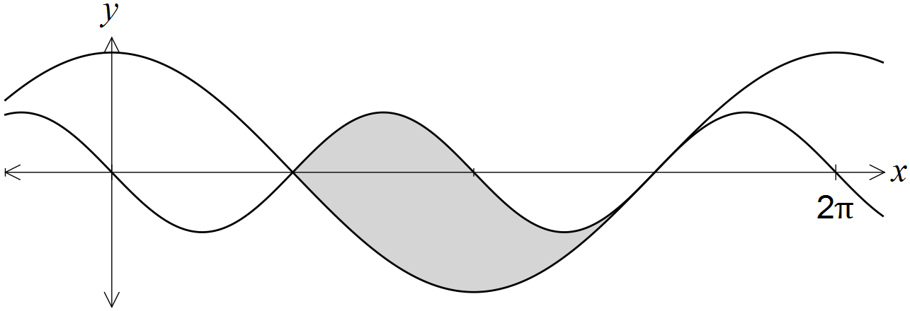

Show that the area of the region is 4 square units.

Question 14 (14 marks)

(a) Determine the mean of a Bernoulli distribution with variance of 0.24. (3 marks)

(b) A Bernoulli trial, with probability of success p, is repeated n times. The resulting distribution of the number of successes has an expected value of 5.76 and a standard deviation of 1.92. Determine n and p. (4 marks)

(c) The probability that a student misses their bus to school is 0.2, and the probability that they miss the bus on any day is independent of whether they missed it on the previous day.

Over five consecutive weekdays, what is the probability that the student

(i) only misses the bus on Tuesday? (2 marks)

(ii) misses the bus at least twice? (2 marks)

(iii) misses the bus on Tuesday and on two other days? (3 marks)

Question 15 (9 marks)

A particle moves in a straight line according to the function  , , where t is in seconds and x is the displacement of the particle from a fixed point O, in metres.

(a) Determine the velocity function, , for the particle. (2 marks)

(b) Determine the displacement of the particle at the instant it is stationary. (2 marks)

(c) Show that the acceleration of the particle is always positive. (2 marks)

(d) After five seconds, the particle has moved a distance of k metres.

(i) Explain why . (1 mark)

(ii) Calculate k. (2 marks)

Question 16 (8 marks)

The discrete random variable Y has the probability distribution shown in the table below.

|  |  |  |  |  |  |
| --- | --- | --- | --- | --- | --- |
|  | -2 | -1 | 0 | 1 | 2 |
|  | 0.4 | 0.2 | 0.1 | 0.1 | 0.2 |

(a) Determine . (2 marks)

(b) Calculate

(i) . (2 marks)

(ii) . (1 mark)

(c) Calculate

(i) . (2 marks)

(ii) . (1 mark)

Question 17 (8 marks)

The graph of , the derivative of a polynomial function f, is shown below. The graph of  has stationary points when ,  and , points of inflection when  and , and roots when ,  and , where .

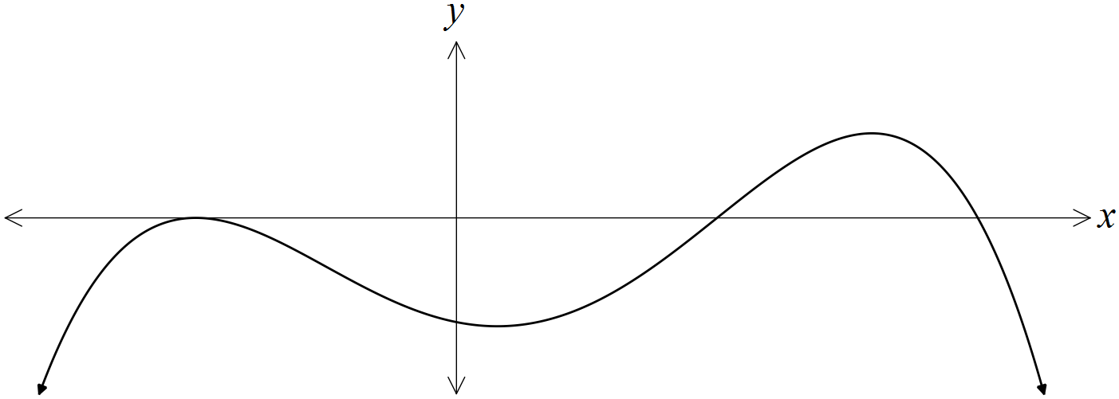

(a) For what value(s) of x does the graph of  have a point of inflection? (1 mark)

(b) Does the graph of  have a local maximum? Justify your answer. (2 marks)

(c) Does the graph of  have a horizontal point of inflection? Justify your answer. (2 marks)

(d) On the axis below, sketch a possible graph of . The graph of  is shown with a broken line for your reference. (3 marks)

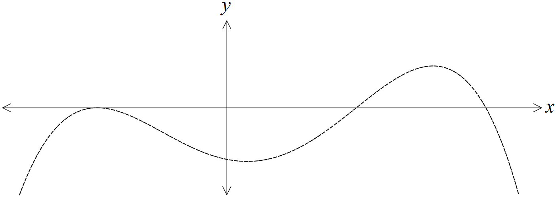

Question 18 (8 marks)

The graph of the function  is shown below for .

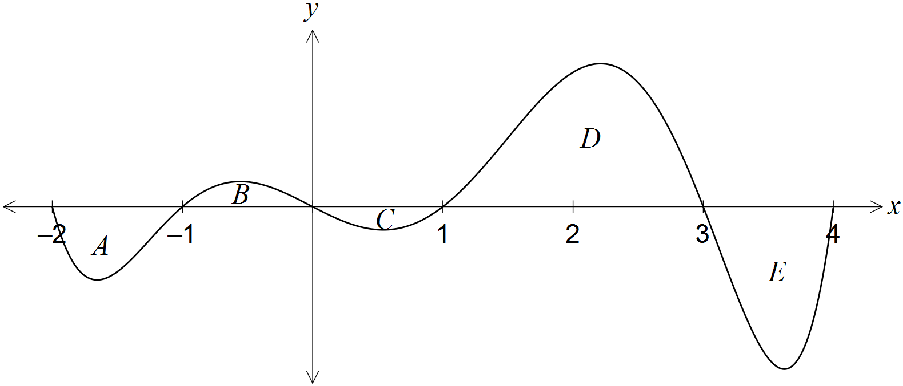

The area of regions enclosed by the x-axis and the curve, A, B, C, D and E, are 12, 7, 5, 32 and 21 square units respectively.

(a) Determine the value of  . (2 marks)

(b) Determine the area of the region enclosed between the graph of  and the x-axis from  to . (2 marks)

(c) Determine the values of

(i) . (2 marks)

(ii) . (2 marks)

Question 19 (7 marks)

Three telecommunication towers, A, B and C, each need underground power cable connections directly to a new power station, P, that is to be built  km from depot D on a 10 km road running east-west between D and A.

Tower B lies 4 km due north of depot D and tower C lies 7 km south of the depot, as shown in the diagram.

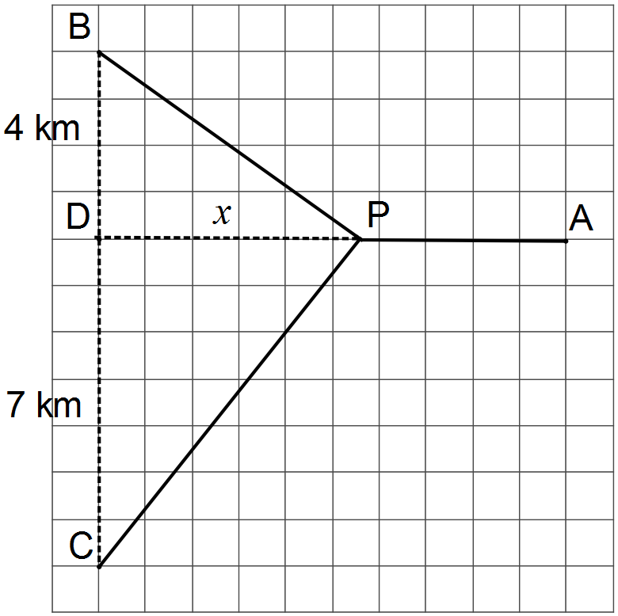

(a) Determine an expression for the total length of underground cable required to connect A, B and C directly to P. (2 marks)

(b) Show that the minimum length of cable occurs when . (3 marks)

(c) Determine the minimum length of cable required, rounding your answer to the nearest hundred metres. (2 marks)

Question 20 (7 marks)

Consider the function  and the function .

(a) Complete the table below. (2 marks)

|  |  |  |  |  |  |  |  |
| --- | --- | --- | --- | --- | --- | --- | --- |
| x | 0 | 1 | 2 | 3 | 4 | 5 | 6 |
|  | 0 | -1.75 |  |  |  |  |  |

(b) For what value(s) of x is the function  increasing? (1 mark)

(c) On the axes below, sketch the graph of  for . (2 marks)

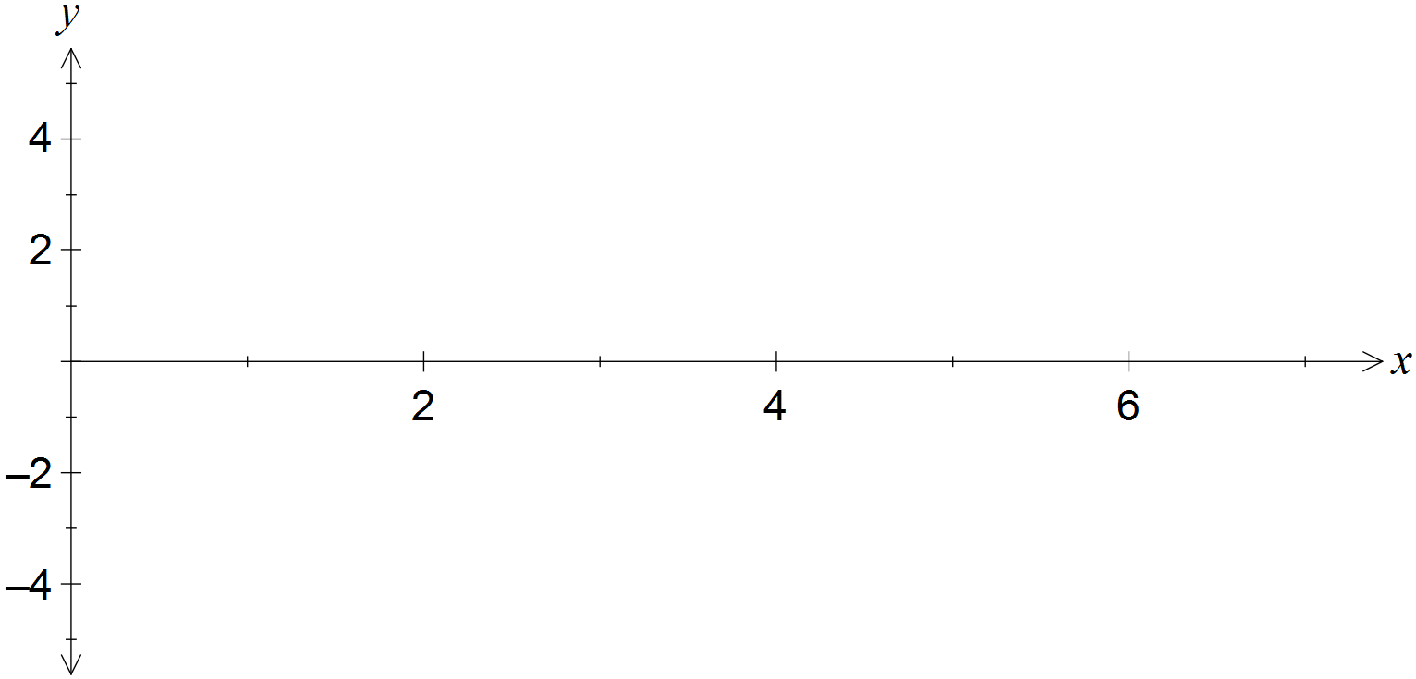

(d) Determine

(i) when . (1 mark)

(ii) the function  in terms of x. (1 mark)

Question 21 (7 marks)

A vertical wall, 2.1 metres tall, stands on level ground and 1.8 metres away from the wall of a house. A ladder, of negligible width, leans at an angle of  to the ground and just touches the ground, wall and house, as shown in the diagram.

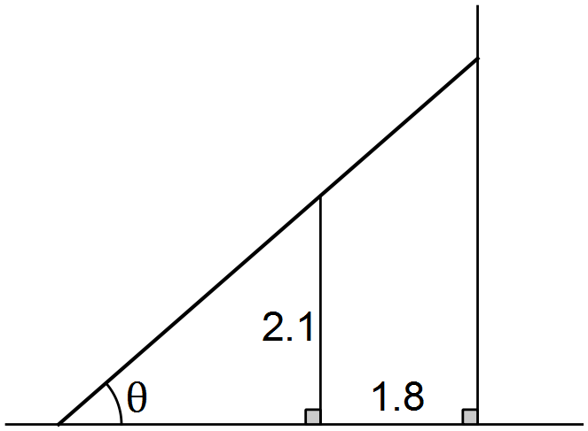

(a) Show that the length of the ladder, L, is given by  . (3 marks)

(b) Use a calculus method to determine the length of the shortest ladder that can touch the ground, wall and house at the same time. (4 marks)

Additional working space

Question number: _________

Additional working space

Question number: _________

© 2016 WA Exam Papers. Narrogin Senior High School has a non-exclusive licence to copy and communicate this paper for non-commercial, educational use within the school. No other copying, communication or use is permitted without the express written permission of WA Exam Papers.